Biology Action Model– Diffusion

Like the gates outside of a stadium controlling the fans that enter and exit a football game, the cell membrane controls which molecules (eg. CO₂, H₂O, O₂, glucose) enter and leave the cell. Molecules that are able to pass through the cell membrane are needed for specific functions within the cell. For example, cell membranes in plants allow water molecules to move into and out of cells. During photosynthesis, plant cells use water to form sugar. The physical and chemical structure of the cell membrane allows some molecules to pass more easily than others. In this way, the cell membrane helps to maintain homeostasis. Homeostasis is the way cells maintain internal conditions like chemical concentrations despite changes to their environment. Cells must maintain homeostasis for survival.

The structure and chemical make-up of the membrane makes it possible for a cell to take in nutrients and keep other potentially harmful/useless molecules out. This structural ability is referred to as permeability. The cell membrane is described as semipermeable because specific molecules are allowed to cross the cell membrane while others are not. For example, some molecules like glucose are too large to pass through the membrane, or are hydrophobic which means they chemically cannot pass through the lipid bilayer. The lipid bilayer is a two-layer barrier composed of hydrophilic heads pointed outward and hydrophobic tails pointed inward. The lipid bilayer allows certain molecules to move across the cell membrane by passive diffusion.

Passive diffusion allows molecules like oxygen and water to move through the cell membrane from a high concentration to a low concentration without using energy. Osmosis is the passive diffusion of water across the cell membrane. Movement of molecules by diffusion and osmosis is driven by a concentration gradient. Molecules such as sugar, water, and CO₂ move passively. A concentration gradient means that there is a difference in the number of molecules inside compared to molecules outside the cell. While it is living, the cell membrane is constantly moving molecules passively across the membrane. Equilibrium is the point at which concentrations of a molecule or compound is equal both inside and outside.

Certain molecules need help to cross the cell membrane because they are too large or charged. In facilitated diffusion molecules pass through the cell membrane with the concentration gradient and the cell expends no energy. It differs from passive diffusion because molecules cross with the help of membrane channel proteins embedded in the lipid bilayer specifically designed for that type of molecule. For example, skeletal muscle cells use specially designed channel proteins to move glucose through the membrane by facilitated diffusion.

Active transport is the final method cells use to transport molecules across the membrane. In active transport, energy in the form of ATP is required by a channel protein to allow the molecule cross the membrane. ATP docks on the channel protein causing a change in its shape allowing a molecule to move from low to high concentration—against the concentration gradient. For example, using the energy of ATP the cell membrane of a nerve cell pumps three sodium molecules across the membrane from an area of low to an area of high sodium concentration. Nerve cells pump sodium and potassium molecules across the membrane to create a nerve impulse.

Cell Transport

Cell Membrane
The cell membrane or plasma membrane performs a number of important functions for the cell. These functions include the separation of the cell from its outside environment, controlling which molecules enter and leave the cell, and recognition of chemical signals. The cell membrane consists of two layers of phospholipids with proteins embedded within these layers. The surface of the cell contains molecules which recognize other molecules which may attach to or enter the cell.

Cell Membrane Structure
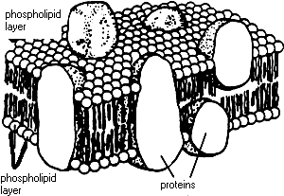

Membrane Processes
The processes of diffusion and active transport are important in the movement of materials in and out of cells.
Diffusion
Diffusion or passive transport is the movement of materials from a region of higher to a region of lower substance concentration. The diagram at the right shows the movement of molecules from higher concentration on side A to a lower concentration on side B. | 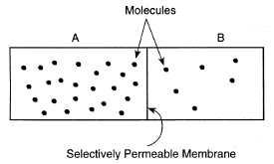

Active Transport
In active transport, molecules move from a region of lower concentration to a region of higher concentration. As this process does not naturally occur, the cell has to use energy in the form of ATP to make active transport occur. | 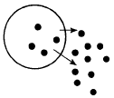

Name: Date:

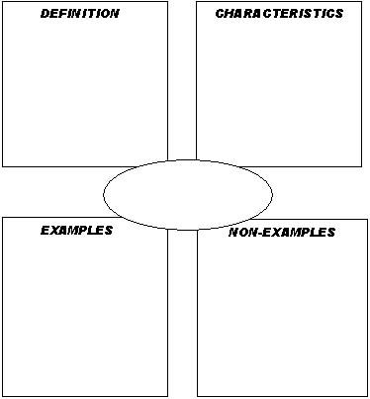

Name: Date:

Name: Date:

Vocabulary for the Day

Active Transport
Concentration
Concentration Gradient
Diffusion
Equilibrium
Homeostasis
Kinetic Energy
Osmosis
Passive Transport
Semipermeable
Solute
Solvent
Solution

Name: Date:

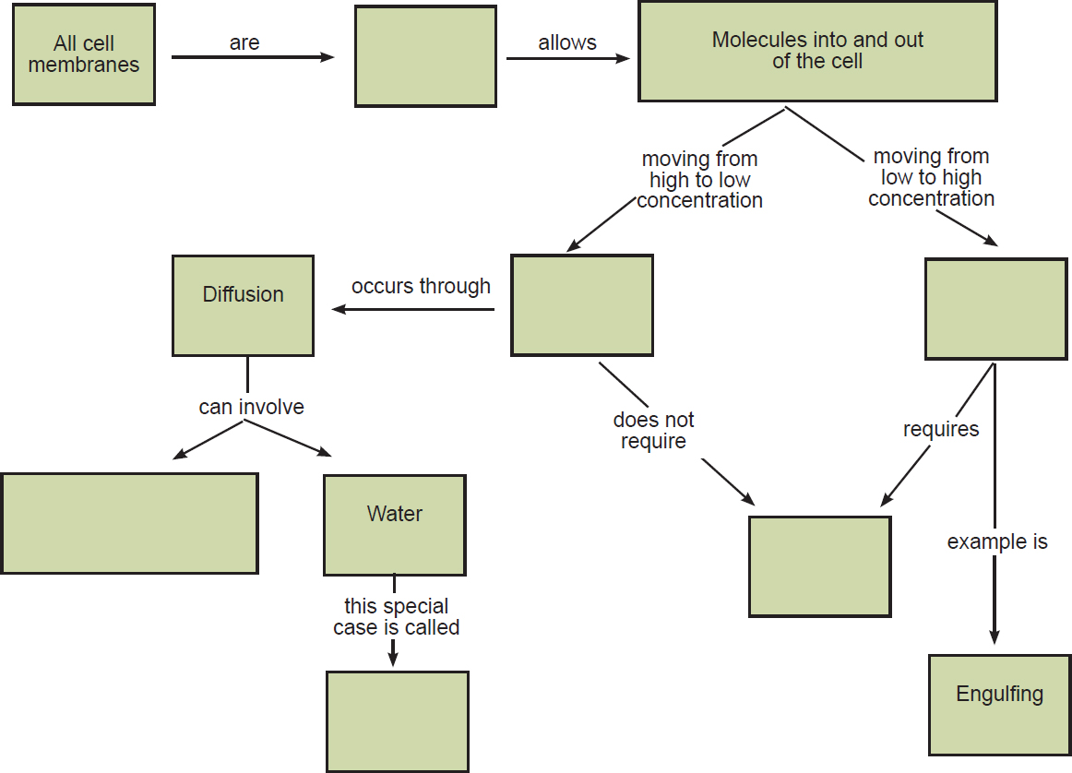

Name: Date:
Jigsaw Questionnaire

Directions: Answer the questions below in the space provided. Answer all questions in complete sentences. You may use your notes taken and the reading given.

- How does the cell membrane allow only some molecules to pass through?

- Describe and give an example of passive diffusion.

- How does water cross the cell membrane?

- Why do some molecules like sodium and potassium require energy to cross the cell membrane?

- Discuss two reasons why semi-permeability is important to a cell.

Name: Date:

Pre Lab Questionnaire
Molecules tend to move from areas of _______ concentration to areas of ______ concentration.
What's in the Bag?
1. Is the baggie or beaker more concentrated in starch?
2. Is the baggie or beaker more concentrated in iodine?

Make Some Predictions
1. If the baggie was permeable to starch, which way would the starch move, into the bag or out
of the bag? ___ _____

2. If the baggie was permeable to iodine, which way would the iodine move, into or out of the
bag? _______

3. If the baggie was permeable to iodine, what color would you expect the solution in the
baggie to turn? _______ What about the solution in the beaker? ___________

4. If the baggie was permeable to starch, what color would you expect the solution in the
baggie to turn? __ ______ What about the solution in the beaker? ___ ______

5. Make a prediction about what you think will happen:
Hypothesis:

Data Table
 | Starting Color | Color after 15 minutes
Solution in Beaker

Solution in Bag

Post Lab Analysis
- Based on your observations, which substance moved, the iodine or the starch?

2. How did you determine this?

3. The plastic baggie was permeable to which substance?

4. Is the plastic baggie selectively permeable?

5. Sketch the cup and baggie in the space below. Use arrows to illustrate how diffusion occurred in this lab.

6. Would your results have changed if you had used hot water rather? Why? Explain

7. Does temperature play a role in the rate of diffusion? How?

8. What would happen if you did an experiment in which the iodine solution was placed in the baggie, and the starch solution was in the beaker?
Be detailed in your description.

9. Why is it not a good idea to store iodine in a plastic bag?

Name: Date:

- You are a college professor who has been asked to explain to a freshman Biology class the significance of Osmosis in Living Organisms.

- To do this you need to address the following questions:

    - How can cause and effect help explain your findings?
    - What is homeostasis?
    - Why do cells need to maintain homeostasis?
    - How do they accomplish that?
    - How is Osmosis applicable to real life?

- Use your notes and the information obtained from the following websites for your research.
  - http://www.buzzle.com/articles/importance-of-osmosis-in-living-organisms.html
  - http://www.buzzle.com/articles/osmosis-examples-of-osmosis.html
  - http://education.seattlepi.com/examples-osmosis-3608.html

- You are a doctor who has a patient that is suffering from kidney failure. The patient is a 12 year old boy. Before starting treatment you need to explain the treatment process to your patient’s family who does not have any science background.

- To do this you need to address the following questions:

    - How can cause and effect help explain your findings?
    - What is homeostasis?
    - Why do cells need to maintain homeostasis?
    - How do they accomplish that?
    - How is Diffusion and Osmosis applicable to this process?

- Use your notes and the information obtained from the following websites for your research.
  - http://ezinearticles.com/?Principles-of-Osmosis-and-Diffusion-in-Dialysis-Treatment&id=8173587
  - http://www.sv.vt.edu/classes/MSE2034_NoteBook/MSE2034_kriz_NoteBook/diffusion/apps/body.html

- You are a Scientist that has been asked by the government of Saudi Arabia to help them provide drinking water for their state. Due to a recent change in weather pattern, Saudi Arabia has experienced desertification leading to a shortage in their drinking water supply. However, Saudi Arabia is surrounded by ocean and the government would like to know how they can harness the ocean water to solve their drinking water shortage problem.

- To do this you need to address the following questions:

    - How can cause and effect help explain your findings?
    - What is Osmosis?
    - What is Reverse Osmosis?
    - How does Reverse Osmosis work?
    - How can Reverse Osmosis help provide drinking water?
    - Are there any other uses of Reverse Osmosis?

- Use your notes and the information obtained from the following websites for your research.
  - http://science.howstuffworks.com/reverse-osmosis.htm

Research/Presentation Rubric

 | 1 | 2 | 3 | 4
Knowledge | All scientific vocabulary, facts, theories & explanations are complete and correct. | Most scientific vocabulary, facts, theories & explanations are complete or correct. | Most scientific vocabulary, facts, theories & explanations are incomplete or incorrect. | All scientific vocabulary, facts, theories & explanations are incomplete or incorrect.
Application | Applies information learned from notes and research to accurately explain, analyze, evaluate and synthesize information. | Applies most information learned from notes and research to accurately explain, analyze, evaluate and synthesize information. | Applies some information learned from notes and research to explain, analyze, evaluate and synthesize information. Some analyses are inaccurate or incomplete. | Didi not apply information learned from notes and research to explain, analyze, evaluate and synthesize information.
Communication | Oral and/or visual/written  communication is well organized and presented in a clear, loud voice. | Oral and/or visual/written  communication is organized but presentation is hard to understand. | Some Oral and/or visual/written  communication is not organized  & presentation is hard to understand. | All of the written, oral or  visual communication is missing and/or lacks organization.

Total Points (20):

Comments:

Name: Date:

Demonstrating Diffusion, Osmosis, and Active Transport

Directions:
Below are models drawn depicting diffusion, osmosis and active transport. After analyzing the models answer the questions that follow using scientific vocabulary. Use the word-bank below to help answer the questions.

Word Bank
concentration gradient molecules homeostasis semipermeable passive diffusion osmosis facilitated diffusion active transport lipid bilayer equilibrium

Model 1
Passive Diffusion: (Before)  O₂ | Passive Diffusion: (After)  O₂
  Inside cell  Outside Cell  Yarn= semipermeable  membrane | Inside cell  Outside cell
Questions for your model:

- Explain what causes oxygen molecules to move across the membrane.

- What is passive diffusion?

- What are some molecules that can move by passive diffusion?

Model 2
Osmosis: (Before)        Na+ H₂O | Osmosis: (After)    Na+ H₂O
Yarn=Semipermeable  Membrane  Inside Cell Outside Cell | Inside cell | Outside cell
Questions for your model:

- In the beginning, there is more Sodium ________the cell. There is more water

_________the cell.

- Explain why water molecules move across the membrane.

3. After the diffusion of water, how much water is inside the cell compared to outside the cell? Why? How much sodium? Why?

Model 3
Facilitated Diffusion: Before | Facilitated Diffusion: After
 | Glucose 
Glucose Channel Protein | Channel Protein
Inside cell Outside Cell | Inside Cell Outside Cell
Questions for your model:

Recall channel proteins are embedded within the membrane

- Why do glucose molecules require a channel protein?

- How is the transport of glucose the same as passive diffusion? How is it different?

- Why is the diffusion of glucose “facilitated”?

Model 4
Active Transport: (Before)  ATP Channel Na+ H₂O Protein | Active Transport: (After)  ATP Channel Na+ H₂O Protein
Inside  cell  Outside cell | Inside cell Outside cell
Questions for your model:

Recall, in active transport molecules require energy in the form of ATP to cross the channel.
Note: The energy provided by ATP, not concentration gradients, moves molecules in active transport. Molecules do not need to reach equilibrium.

- Describe and explain how sodium molecules move across the membrane.

- What is necessary for a molecule to move with active transport?

- Why do molecules like sodium enter the cell by active transport and not passive diffusion?

Give an example of a cell that uses active transport to move molecules across its membrane.

Explanation:

