
Adapted From: http://www.education.ky.gov/users/otl/cca_dok/cca_dok_support_808_mathematics.pdf

Webb’s Depth of Knowledge
For Mathematical Thought

Recall and Reproduction – Depth of Knowledge (DOK) Level 1
Recall and Reproduction includes the recall of information such as a fact, definition, term, or a simple procedure, as well as performing a simple algorithm or applying a formula. That is, in mathematics a one-step, well-defined, and straight algorithmic procedure should be included at this lowest level. Other key words that signify a Level 1 include “identify,” “recall,” “recognize,” “use,” and “measure.” Verbs such as “describe” and “explain” could be classified at different levels depending on what is to be described and explained.
Some examples that represent but do not constitute all of Level 1 performance are:
- Identify a diagonal in a geometric figure.
- Multiply two numbers.
- Find the area of a rectangle.
- Convert scientific notation to decimal form.
- Measure an angle.

Skills and Concepts/Basic Reasoning – Depth of Knowledge (DOK) Level 2
Skills and Concepts/Basic Reasoning includes the engagement of some mental processing beyond a habitual response. A Level 2 assessment item requires students to make some decisions as to how to approach the problem or activity, whereas Level 1 requires students to demonstrate a rote response, perform a well-known algorithm, follow a set procedure (like a recipe), or perform a clearly defined series of steps. Keywords that generally distinguish a Level 2 item include “classify,” “organize,” ”estimate,” “make observations,” “collect and display data,” and “compare data.” These actions imply more than one step. For example, to compare data requires first identifying characteristics of the objects or phenomenon and then grouping or ordering the objects. Some action verbs, such as “explain,” “describe,” or “interpret” could be classified at different levels depending on the object of the action. For example, if an item required students to explain how light affects mass by indicating there is a relationship between light and heat, this is considered a Level 2. Interpreting information from a simple graph, requiring reading information from the graph, also is a Level 2. Interpreting information from a complex graph that requires some decisions on what features of the graph need to be considered and how information from the graph can be aggregated is a Level 3. Caution is warranted in interpreting Level 2 as only skills because some reviewers will interpret skills very narrowly, as primarily numerical skills, and such interpretation excludes from this level other skills such as visualization skills and probability skills, which may be more complex simply because they are less common. Other Level 2 activities include explaining the purpose and use of experimental procedures; carrying out experimental procedures; making observations and collecting data; classifying, organizing, and comparing data; and organizing and displaying data in tables, graphs, and charts.
Some examples that represent but do not constitute all of Level 2 performance are:
- Classify quadrilaterals.
- Compare two sets of data using the mean, median, and mode of each set.
- Determine a strategy to estimate the number of jellybeans in a jar.
- Extend a geometric pattern.
- Organize a set of data and construct an appropriate display.

Strategic Thinking/Complex Reasoning – Depth of Knowledge (DOK) Level 3
Strategic Thinking/Complex Reasoning requires reasoning, planning, using evidence, and a higher level of thinking than the previous two levels. In most instances, requiring students to explain their thinking is a Level 3. Activities that require students to make conjectures are also at this level. The cognitive demands at Level 3 are complex and abstract. The complexity does not result from the fact that there are multiple answers, a possibility for both Levels 1 and 2, but because the task requires more demanding reasoning. An activity, however, that has more than one possible answer and requires students to justify the response they give would most likely be a Level 3. Other Level 3 activities include drawing conclusions from observations; citing evidence and developing a logical argument for concepts; explaining phenomena in terms of concepts; and using concepts to solve problems. Some examples that represent but do not constitute all of Level 3 performance are:
- Write a mathematical rule for a non-routine pattern.
- Explain how changes in the dimensions affect the area and perimeter/circumference of geometric figures.
- Determine the equations and solve and interpret a system of equations for a given problem.
- Provide a mathematical justification when a situation has more than one possible outcome.
- Interpret information from a series of data displays.

Extended Thinking/Reasoning – Depth of Knowledge (DOK) Level 4
Extended Thinking/Reasoning requires complex reasoning, planning, developing, and thinking most likely over an extended period of time. The extended time period is not a distinguishing factor if the required work is only repetitive and does not require applying significant conceptual understanding and higher-order thinking. For example, if a student has to take the water temperature from a river each day for a month and then construct a graph, this would be classified as a Level 2. However, if the student is to conduct a river study that requires taking into consideration a number of variables, this would be a Level 4. At Level 4, the cognitive demands of the task should be high and the work should be very complex. Students should be required to make several connections—relate ideas within the content area or among content areas—and have to select one approach among many alternatives on how the situation should be solved, in order to be at this highest level. Level 4 activities include designing and conducting experiments; making connections between a finding and related concepts and phenomena; combining and synthesizing ideas into new concepts; and critiquing experimental designs.
Some examples that represent but do not constitute all of Level 4 performance are:
- Collect data over time taking into consideration a number of variables and analyze the results.
- Model a social studies situation with many alternatives and select one approach to solve with a mathematical model.
- Develop a rule for a complex pattern and find a phenomenon that exhibits that behavior.
- Complete a unit of formal geometric constructions, such as nine-point circles or the Euler line.
- Construct a non-Euclidean geometric shape.

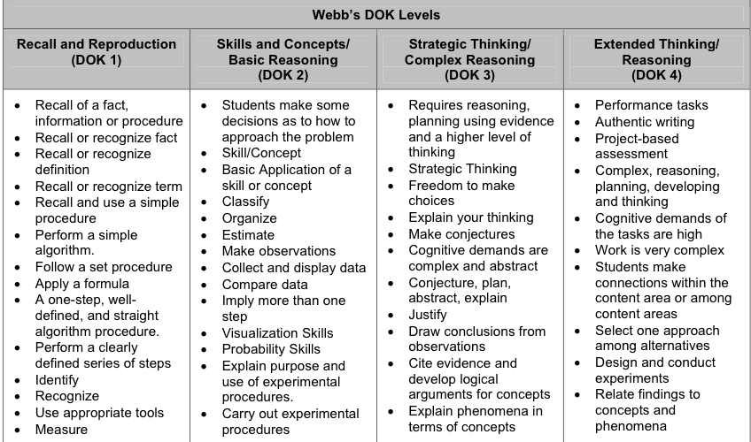

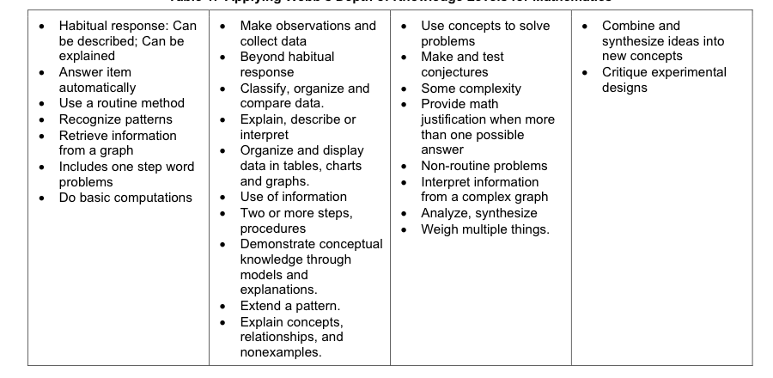

Sample Breakdown of a Standard

Common Core Content Standard – 5.OA.3 (5th Grade Operations and Algebraic Thinking)
Generate two numerical patterns using two given rules. Identify apparent relationships between corresponding terms. Form ordered pairs consisting of corresponding terms from the two patterns, and graph the ordered pairs on a coordinate plane.
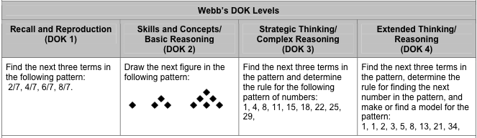

Common Core Content Standard – G-SRT.2 (High School Geometry)
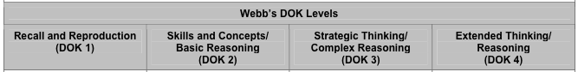
Given two figures, use the definition of similarity in terms of similarity transformations to decide if they are similar; explain using similarity transformations the meaning of similarity for triangles as the equality of all corresponding pairs of angles and the proportionality of all corresponding pairs of sides.

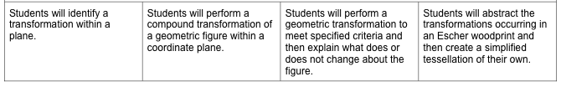

Sample Problems
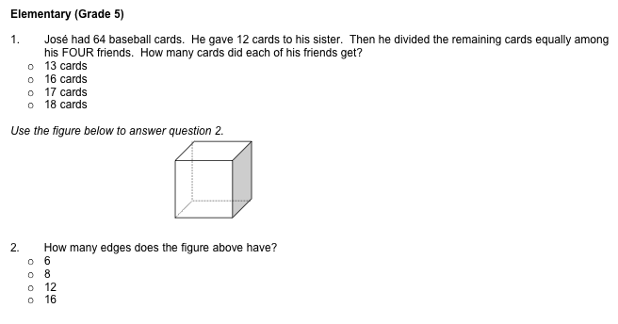
Math Standards Elementary Grade 5

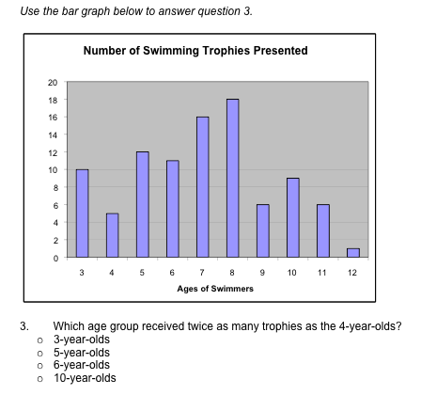

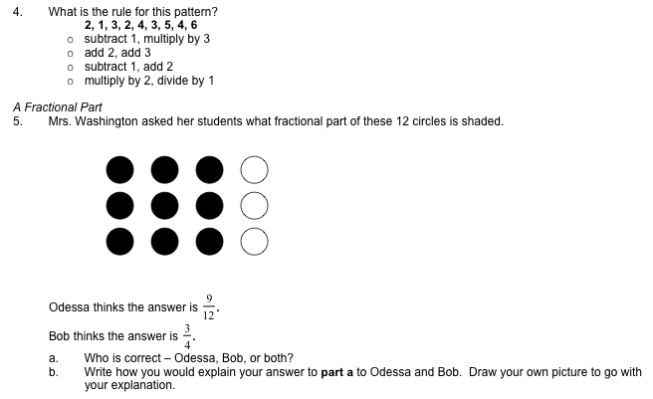

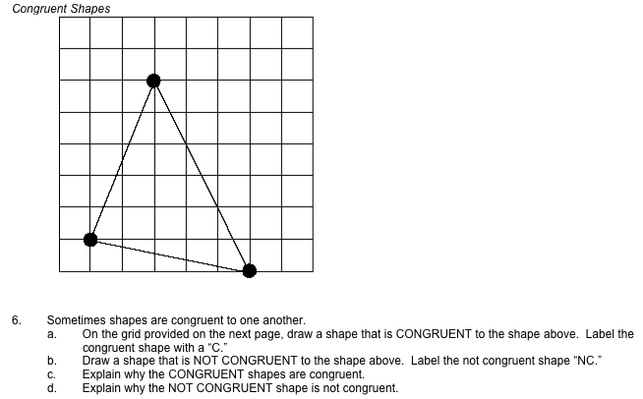

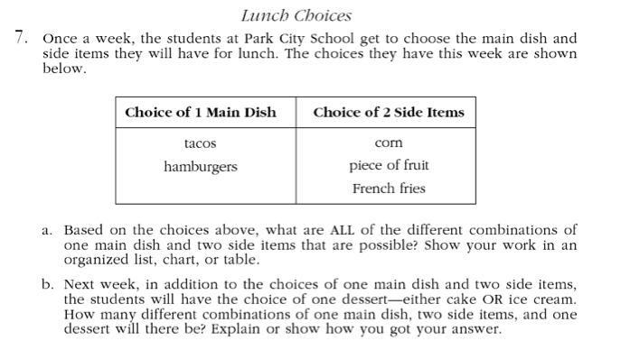

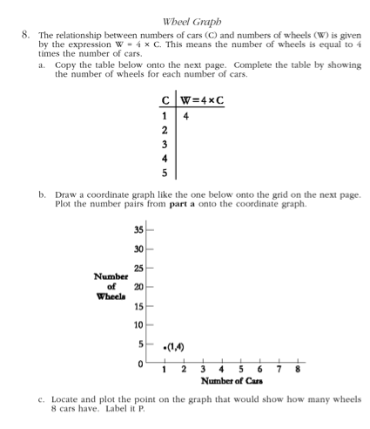

Sample Problems
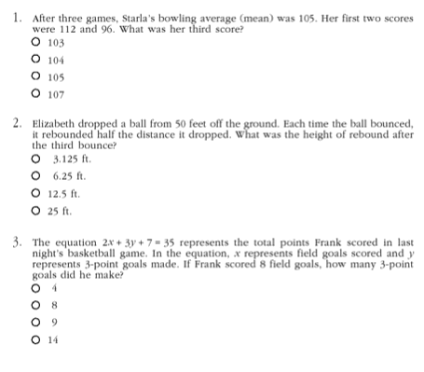
Math Standards Middle School Grade 8

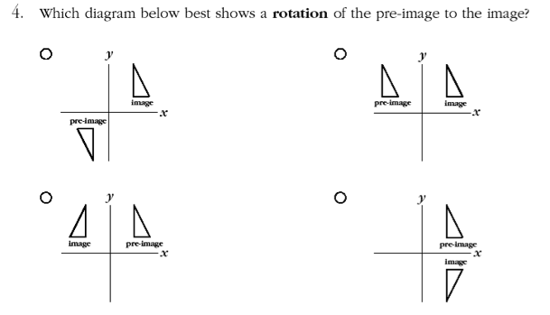

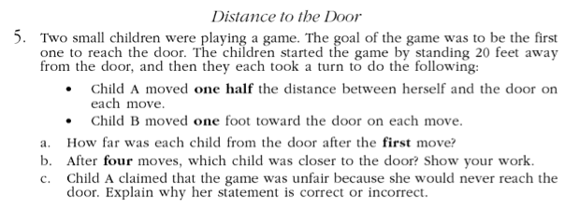

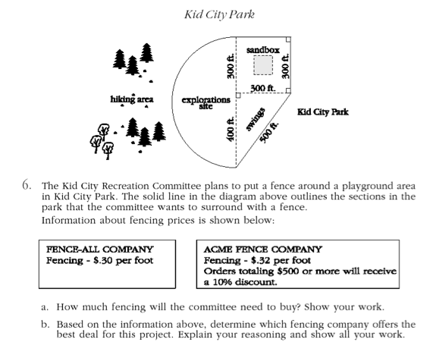

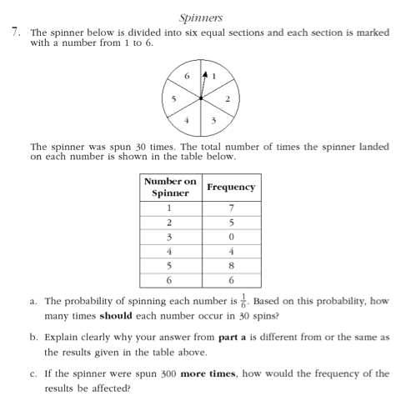

Sample Problems
Math Standards High School Grade 11
