GLOBAL WARMING WRAP-UP/EXTENSION PROJECT

Goals:
1) Demonstrate your understanding of the causes and effects of the greenhouse effect and its impact on society and the environment.
2) Come up with and propose possible solutions to a “city” that is contributing to global warming.

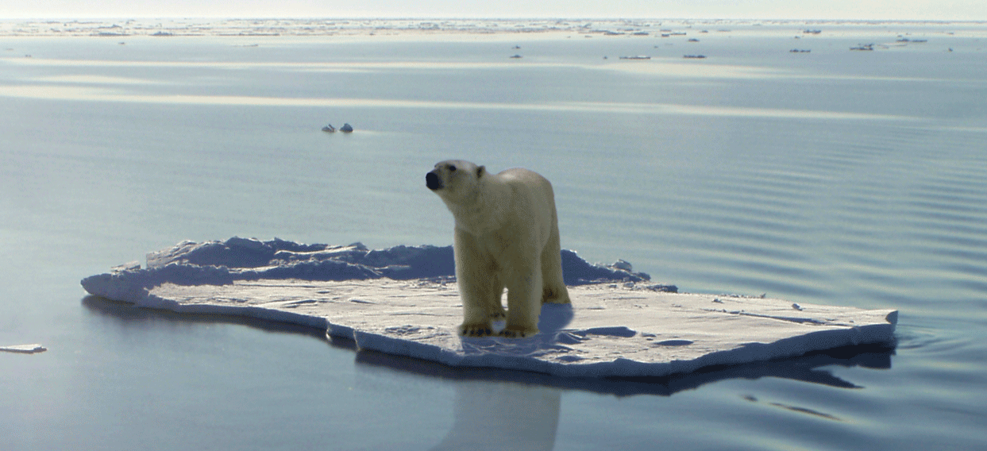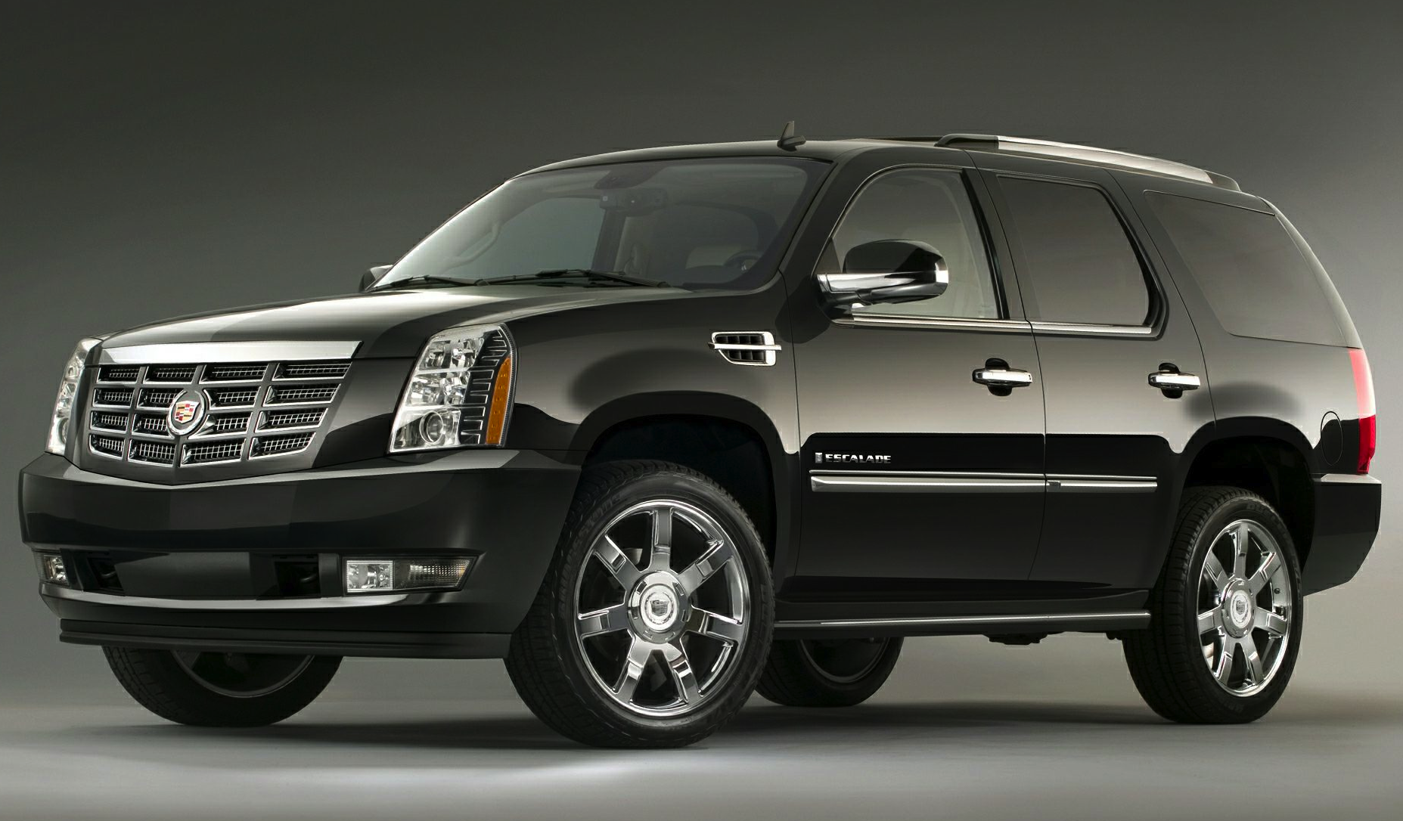
The Facts:

The city of Escalade, Michigan is home to the factory that produces the Cadillac Escalade, a gas-guzzling luxury SUV (Sports Utility Vehicle) that gets between 14-18 miles per gallon of gasoline. The Escalade factory depends on electricity from the city’s coal-burning power plant, which, together with the Escalade factory, provides jobs for about half the population of Escalade, Michigan. However, this city is lucky in that it is sunny in Escalade about 200 days every year, and there is an almost constant breeze over the Escalade Cliffs on the edge of town by the powerful Escalade River.

Your Assignment:

As a concerned citizen worried about the effects of global warming and your city’s production of greenhouse gases, you will go before the Esplanade City Council to explain how your city is contributing to global warming and to propose three changes the city can make to reduce its impact on the environment and society. You will have 3 minutes to propose your ideas for changes that will benefit both the city of Escalade and reduce your city’s production of greenhouse gases. Just remember, the “mayor” not agree with all of your ideas, so be prepared to defend them!

