Pathways to Graduation
Chancellor’s Day Professional Learning
November 3, 2015

Facilitator: Muriel Zwick
Math Specialist/Queens

Topic: Polynomials
Polynomials
Today, we will determine the end behavior of a polynomial graph by analyzing the equation of a polynomial of a high degree. We will also create polynomial graphs during hands-on activities for a deeper understanding of polynomials. This is an HSE level TASC Math skill that can be replicated in the classroom.
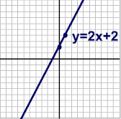
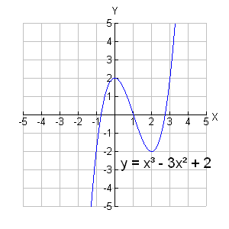
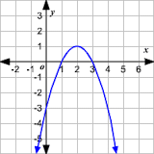



High Emphasis:
Algebra: Arithmetic with Polynomials and Rational Expressions
· A-APR.1 - Understand that polynomials form a system analogous to the integers, namely, they are closed under the operations of addition, subtraction, and multiplication; add, subtract, and multiply polynomials.
· A-APR.3 - Identify zeroes of polynomials when suitable factorizations are available, and use the zeroes to construct a rough graph of the function defined by the polynomial.



TASC TEST BLOG

Polynomials Operations and Graphs | Math
THETASCTEST

Your study sessions should be as effective and efficient as possible. To help, we outlined some of the major components of each section of the TASC Test Assessing Secondary Completion™.

We’ll start by looking at an important aspect of math. Polynomials are one of the areas of high emphasis for the TASC test math section, and it’s important that you learn how to recognize and approach these mathematic expressions. Start working with polynomials, and learn more about TASC test math study skills: Polynomials The technical definition of a polynomial is: “an algebraic expression of more than one term, constructed from variables and constants using only the operations of addition, subtraction, multiplication and non-negative whole-number exponents.” An easy way to keep this definition in mind is to remember that: poly means many, and nominal means terms. In other words, a polynomial is a math problem with more than one term. In this case, it contains more than one algebraic term — a phrase that contains numbers, variables (represented by letters, like x and y) and operators (such as add, subtract, and multiply).

A polynomial might look like this, for example:
8xy2 + 6x – 10
This example has three terms. In these types of equations, you might find constants, variables, or exponents. These can all be combined by using addition, subtraction, multiplication, or division. But you should know that a polynomial is not an expression that is divided by a variable. (Like 2/x, for example.) Whenever you’re working with a polynomial, you should know that — whether you add or multiple polynomials — your result is a polynomial! As you work through the operations, it’s best to use Standard Form, which means you put the equation in order of highest rank. The example above is in Standard Form because xy2 is greater than x.

When you work through a polynomial equation, you combine like terms. For example:
(8xy2 + 6x – 10) + (2xy2 – 4x + 12) = 10xy2 + 2x + 2

How to Graph Polynomials You may also be asked to graph a polynomial. Polynomials with one variable are easy to graph — and to recognize, because they have smooth and continuous lines. Sometimes, you may have to combine multiple polynomials before you can graph the equation. Remember to put the polynomial in standard form before combining. This will make it easier for you to find the like terms and discover which variables must be graphed.

Start the discussion…

- The Difference Between Linear and Exponential Function Mathematics

Finding the Minimum or Maximum of Quadratic Functions | Mathematics

Graphing Quadratic Functions | Mathematics
Read Article

Polynomials are finite sums of terms where the exponents on the variables are not negative numbers and the terms are separated by plus and minus signs.

Monomials  (one term) | Binomials  (two terms) | Trinomials  (three terms)
4x | 5x - 1 | 10x² – 7x +5
3x²yz⁶ | 10x + y | 2ab³ – 6ab² - 8ab
10xy | 12x² – 5x³ | 5y² -6y + 3
5y³ | 6x⁴ + 4y | x³ +5x - 6
6x² | x³ - 2 | 4x² + 2x -3
Graphing Polynomial Functions
To sketch any polynomial function, you can start by finding the real zeros of the function and end behavior of the function .
Steps involved in graphing polynomial functions:
1. Predict the end behavior of the function.
2. Find the real zeros of the function. Check whether it is possible to rewrite the function in factored form to find the zeros.
A real zero of a function is a real number that makes the value of the function equal to zero.
3. Make a table of values to find several points.
4. Plot the points and draw a smooth continuous curve to connect the points.
5. Make sure that the graph follows the end behavior as found in the above step.

The Degree of a Polynomial
The degree of a polynomial is the term with the highest exponent..
Ex: 4x⁷ + 7x – 3
Polynomial degree: 7
Leading term: 4x⁷
Leading coefficient: 4

Ex: 2x² + x + 5 + x²
Combine like terms = 3x² + x + 5
Polynomial degree: 2
Leading term: 3x²
Leading coefficient: 3

Predict the end behavior of a function
The appearance of a graph as it is followed farther and farther in either direction. For polynomials, the end behavior is indicated by drawing the positions of the arms of the graph, which may be pointed up or down.

Polynomial End Behavior:
1. If the degree n of a polynomial is even and the leading coefficient is positive, then the arms of the graph are both pointing up.
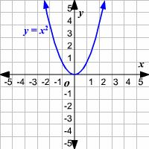
Ex: y = x²
Parabola
Quadratic function

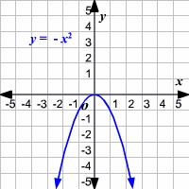
2. If the degree n of a polynomial is even, and the leading coefficient is negative, then the arms of the graph are both pointing down.
Ex: y = -x²
Parabola
Quadratic function

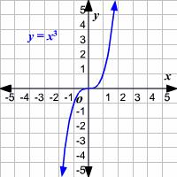
3. If the degree of a polynomial is odd and the leading coefficient is positive, the right arm of the graph is moving up in a positive direction along the x-axis.
Ex: y = x³

4. If the degree of a polynomial is odd and the leading coefficient is negative, the right arm of the graph is moving up in a negative direction along the x-axis.
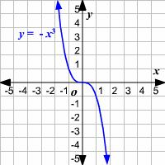
Ex: y = -x³

Finding the Roots or Real Zeros of a Function:
The roots or zeros of a function are the x-values for which the function is equal to zero or graphically, the values where the graph intersects the x-axis. To solve for the roots of a function, set the function equal to zero and solve for x.

Examples:
f(x) = x³ -2x² -15x
x(x - 5) (x + 3)
Real zeros = 0, 5, -3
This graph will cross the x-axis at 0, 5 and -3
The degree of the polynomial is odd and the leading exponent is positive, therefore the right arm of the graph will be moving up in a positive direction along the x-axis.

x³ -2x² -15x
x(x - 5) (x + 3)
Real zeros = 0, 5, -3
Make a Table of Values
x | y
5 | 0
4 | -28
3 | -36
2 | -30
1 | -16
0 | 0
-1 | 12
-2 | 14
-3 | 0

Next step, plot the points from the table above.
Check that the graph flows the correct end behavior.

Example:
Graph the polynomial function f(x) =x³ – 2x² – 3x
The degree of the polynomial is 3 and there would be 3 zeros for the functions.
The function can be factored as x ( x + 1)( x – 3). So, the zeros of the functions are x = –1, 0 and 3.

f(x) = x³ – 2x² – 3x = x ( x + 1)( x – 3
x = 0, x=-1, x=3

Make a table of values to find several points.

x | y
5 | 60
4 | 20
3 | 0
2 | -6
1 | -4
0 | 0
-1 | 0
-2 | -10
-3 | -36

Plot the points and draw a smooth continuous curve to connect the points:
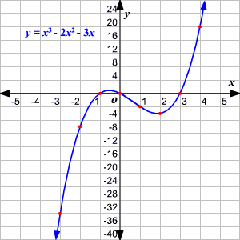

Turning Points: The "hills" or "valleys" where the graph changes direction from increasing to decreasing, or from decreasing to increasing, are often called turning points.

The number of turning points is never more than the degree of the polynomial minus one.
For example, the graph of a 3rd degree polynomial function can have 2 turning points or fewer. [If the degree is n, the number of turning points is at most n - 1. There could be fewer.]

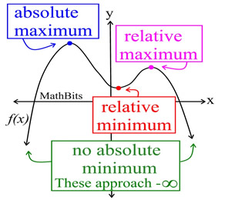

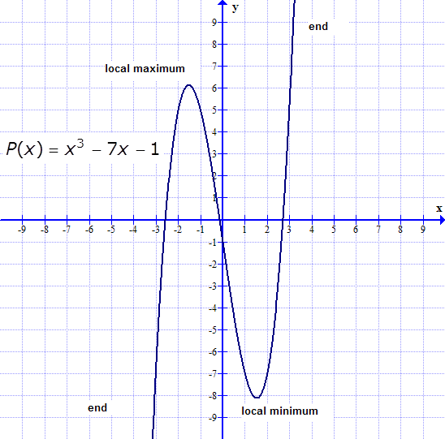

Practice: Sketch the graph of the polynomial function
Show all work below

f(x) = x³ - x² – 6x

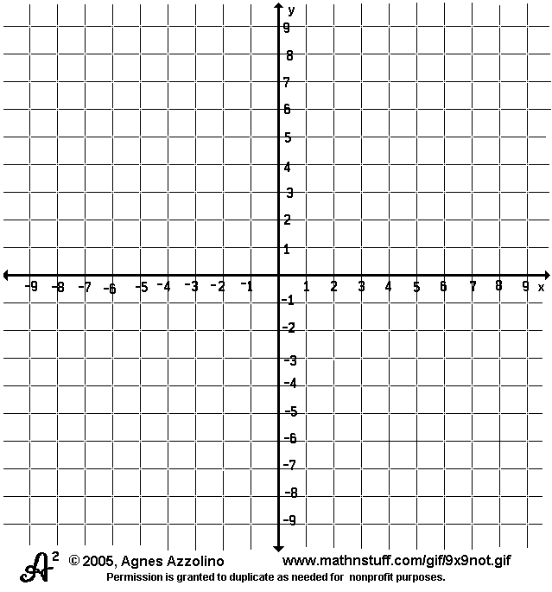

Solution: f(x) = x³ - x² – 6x

End behavior: The degree of a polynomial is odd and the leading coefficient is positive, the right arm of the graph is moving up in a positive direction along the x-axis.

Roots or Zeros of the Polynomial:
x³ - x² – 6x
x ( x² –x -6)
x (x -3) (x + 2)
x = 0, x = 3, x = -2

We now know that the graph will cross the x – axis at x = 0, x = 3, x = -2
Create a table to determine the y-values
x | y
5 | 70
4 | 24
3 | 0
2 | -8
1 | -6
0 | 0
-1 | 4
-2 | 0

Plot the points and draw a smooth continuous curve to connect the points:

