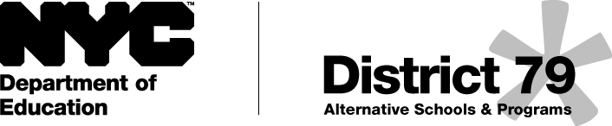

Strategies to Build Reading Comprehension

1. Reading for the Gist
Purpose: Gist is a comprehension strategy that is used both during and after reading. It is one approach to summarizing a text.
How it is used: First, the students will number the paragraphs in the text. Then, after each paragraph, student will stop and identify what the paragraph was mostly about in 20 words or less. Students will use a graphic organizer to record their responses.

2. Section Summaries
Purpose: To teach students how to summarize a larger portion of text.
How it is used: Using a non-fiction passage, students will use a graphic organizer to summarize each heading. Then, students need to identify why that section was important to the article as a whole.

3. Questions, Questions, Questions
Purpose: With this strategy, students go back into the text and create their own questions. It builds comprehension by promoting re-reading and critical thinking about the passage.
How it is used: After reading, students will create 5 questions about the text. The student will indicate which paragraph the answer can be found in. Then, the students will give the graphic organizer with their questions to another student to answer.

4. Frontloading Vocabulary
Purpose: Pre-teaching vocabulary is a before-reading strategy to facilitate comprehension.
How it is used: Before reading, the teacher will choose 4 or 5 vocabulary words from the text and follow the 3 step procedure:
- Teacher provides a description, explanation, or example of the new term.
- Students restate the description in their own words.
- Students construct a graphic or their own definition of the word and write it in their notebook or on a graphic organizer.

5. Somebody-Wanted-But-So
Purpose: This strategy is used during or after reading to help students understand literary elements such as conflicts and resolutions. It is also a great way to teach summarizing of narrative text.
How it is used: During or after reading, students will complete the graphic organizer identifying who wanted something, what they wanted, what conflict arose, and the resolution.

6. Reading & Analyzing Nonfiction (R.A.N.)
Purpose: This strategy is used before, during and after reading to help activate prior knowledge, identify new learning, and raise questions based on new information gathered.
How it is used: Students complete the chart starting with “What I Think I Know.” During reading, if their statement is confirmed, students will put a check mark in the “Confirmed” column. If it is not true, students will put a check in the misconception column. Also during reading, students will note “New Information.” After reading, students will create questions based on the new information they learned.

