Name ______________________________________________________________________ Date __________________
Geometry Diagnostic
Calculators are allowed on this diagnostic
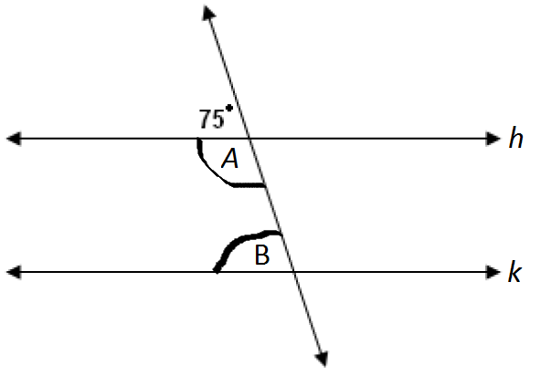
Lines h and k are parallel. One angle in the figure is marked as 75°.
- What is the measure of angle A?

- What is the measure of angle B?

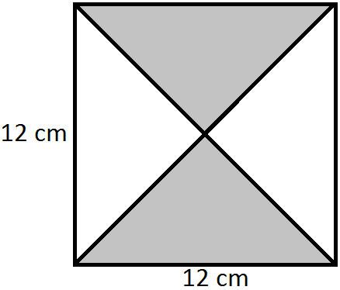
- Mary is making a quilt like the one on the right. What is the area of one of the small triangles in square centimeters?

- The radius of a circle is 6 units. Which of the following expressions will give you the area of the circle?

  - 6π
  - 36π
  - 12/π
  - 6π²

- The radius of a circle is 10 cm. What is the circumference of the circle to the nearest centimeter?

  - 31cm
  - 314cm
  - 628cm
  - 63cm

- The triangles are similar. Calculate the length marked with “x”
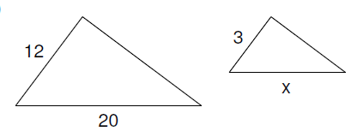

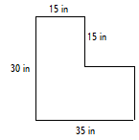
- Find the area of this shape:

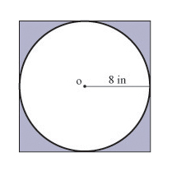
- Find area of the shaded part:

- Find the surface area of a cube with 3 cm sides:

- Find the volume of this cylinder-shaped can. Use 3.14 for Pi.

TOTAL RESULTS
Points: /10 | % Correct:

