D79 Khan Academy Tutorial
What is Khan Academy?

“Khan Academy is a not-for-profit educational organization started by Salman Khan in 2008. Our mission is to provide a free, world-class education to anyone, anywhere.
Our online materials cover subjects ranging from math and finance to history and art. With thousands of bite-sized videos, step-by-step problems and instant data, Khan Academy provides a rich and engaging learning experience. You can earn points and badges along the way, and coach others as well.”

How to get Started:
- Create a teacher account.
  - Instructions can be found here: https://www.khanacademy.org/coach-res/reference-for-coaches/how-to/a/create-your-teacher-account
- Get Your Class Online!
  - Instructions can be found here: https://www.khanacademy.org/coach-res/reference-for-coaches/how-to/a/get-your-class-online
- Adding Students
  - You can invite students if you have their email address.
    - Instructions for that can be found here: https://www.khanacademy.org/coach-res/reference-for-coaches/how-to/a/get-your-class-online
  - OR You can have students add you as their Khan Academy “coach”
    - Instructions for that can be found here: https://www.khanacademy.org/coach-res/reference-for-coaches/how-to/a/how-to-add-a-coach
- Assign Work to Students
  - After students have taken the diagnostic provided through D79, recommend work for them to complete on Khan Academy.
- Login into Khan Academy with your teacher account.
- Click on the “Coach” button in the upper left:
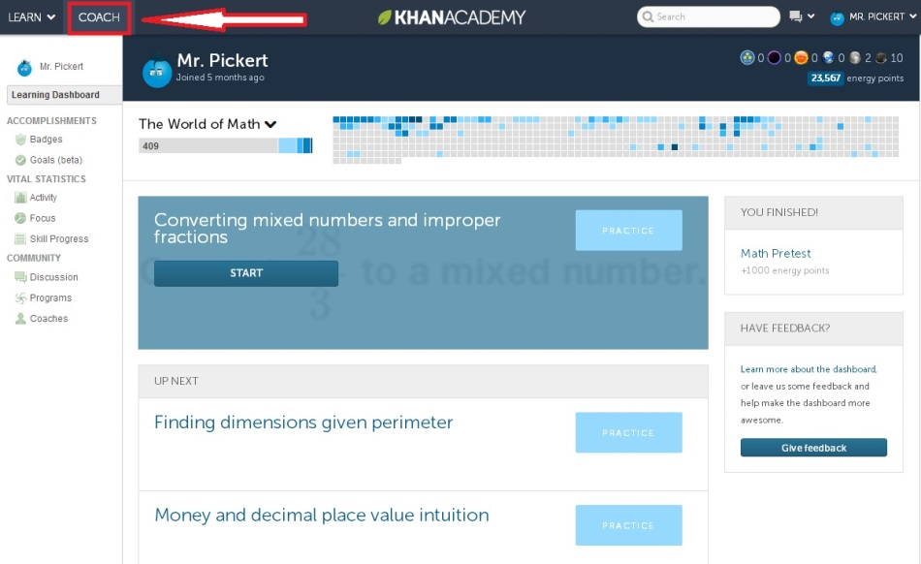

- Next select “By Student” on the menu on the left:
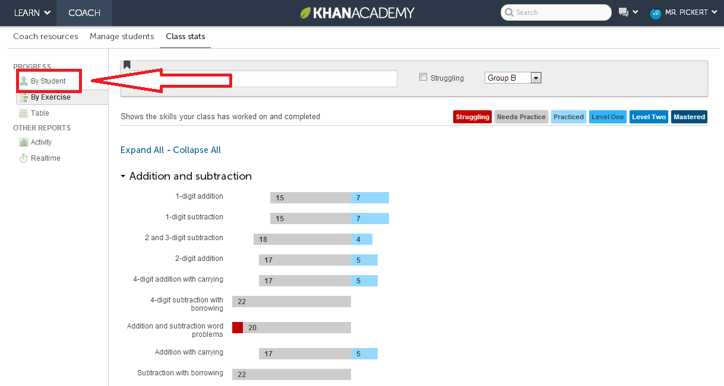

- Make recommendations for students by clicking on their name and the button labeled “Make a Recommendation”:
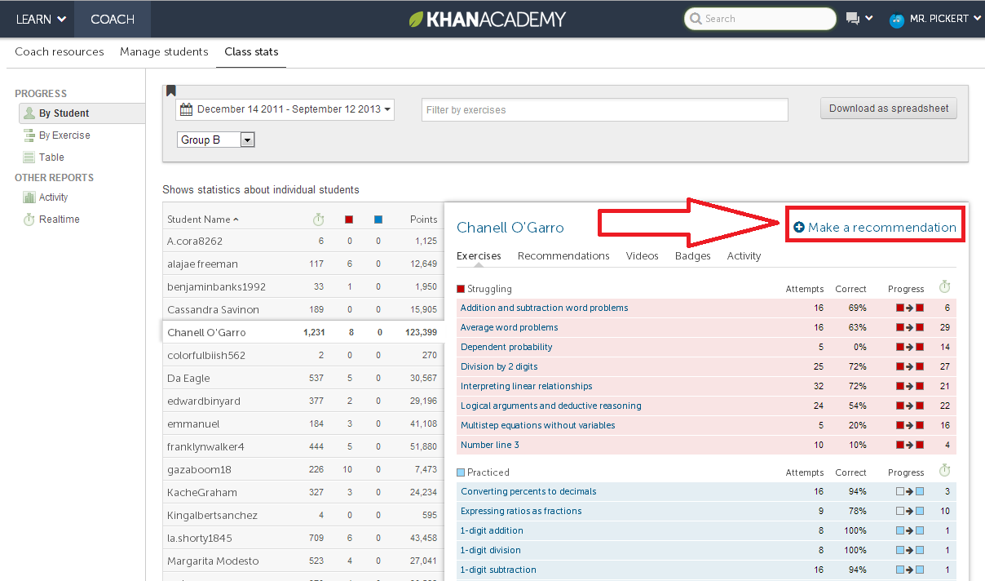

- Recommend work for student based on provided Excel spreadsheet:
