Pathways to Graduation Name:____________________________
Calculator Session Date:______________________________
PRACTICE READINESS TEST

Part 1: Calculator Session

- Solve the system of linear equations below:
x + y = 6 -3x + y = 2

- x = 4; y = 2
- x = 3; y = 3
- x = 1; y = 5
- x = 6; y= -1

- Two joggers run 8 miles north and then 5 miles west. What is the shortest distance, to the nearest tenth of a mile, they must travel to return to their starting point?

- 8.4
- 9.5
- 9.4
- 13.1

- Find the equivalent to the following expression: ( ${\sqrt[3]{x}}^{4}$ ) (${\sqrt[2]{x}}^{6}$ )

A. x^{9/4}
B. x^{3/6}
C. x^{13/3}
D. x^{2/3}

- The city of Atlanta has a population of about 420,003 and an area 133 square miles. What is the population density of Atlanta in people per mile squared to the nearest whole number?

- 5,962
- 2,486
- 3,158
- 1,987

- In the diagram: ││AB is parallel to ││ED, the points B, C and E lie on a straight line, and the points A, C, and D also lie on a straight line. What is the value of e (the length of CD) ?
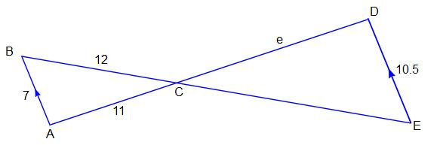

- 14.5
- 17.5
- 16.5
- 18

- The 30 students in a class did a survey of their favorite movie series and recorded the results as follows:
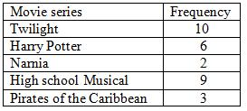

What was the relative frequency for High School Musical?

F. 0.09
G. 0.3
H. 0.33
J. 0.43

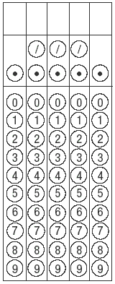
- Find the value of a that makes this equation true:

4 (2a + 3) = -3 (a – 1) +31

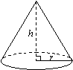
- Calculate the volume of a cone if the height is 12 cm and the radius is 7 cm to the nearest whole number. Use 3.14 for $π$

F. 212 cm³
- 423 cm³
- 914 cm³
J. 615 cm³

- Brian sells homemade lemonade at the local farmers market. He sells containers in quart and gallon sizes. Mr. Santos buys 3 gallons of lemonade from Brian to serve at an outdoor pool party that evening. How many cups can Mr. Santos serve to his guests?

10. The function $f\left(x\right)$is defined on the real numbers by$f\left(x\right)$ = 2 + x - x².
What is the value of $f\left(-3\right)$?

F. -10
G. 8
H. -4
J. 14

STOP

PRACTICE READINESS TEST

Part 2: Non-Calculator Session

- Which statement is not correct?

- A rational number can be written as a ratio.
- An irrational number can be written as a decimal.
- An irrational number can be written as a fraction.
- An irrational number has endless non-repeating digits to the right of the decimal point.

- An electronics store sells DVD players and cordless telephones. The
store makes a $75 profit on the sale of each DVD player (d) and a $30
profit on the sale of each cordless telephone (c). The store wants to
make a profit of at least $255 from its sales of DVD players and
cordless phones. Which inequality describes this situation?

F. 75d + 30c < 255
G. 75d + 30c $≤255$
H. 75d +30c > 255
J. 75d + 30c $≥255$

- Which value of x makes this fraction undefined?
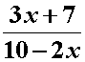

- 10
- -2
- 5
- -5

- Which set of ordered pairs below represents a function?

F. {(5, 2), (6, -1), (1, 1), (4, 3)}
G. {(2, 4), (2, -1), (2, 3), (2,-5)}
H. {(2, -1), (5,-6), (4, 3), (5, 1)}
J. {(3, -1), (6, 2), (3, 4), (2, 6)}

15. Which graph does not represent a function?
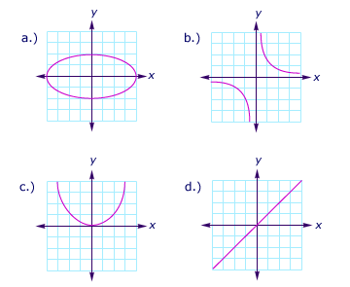

- Graph a does not represent a function.
- Graph b does not represent a function.
- Graph c does not represent a function.
- Graph d does not represent a function.

- A circle has a radius of 3 inches.

Find the length in inches, of an arc subtended by a central angle of 15$0^{0}$.

F. $\frac{π}{3}$

G. 5 $\frac{π}{2}$

H. 4$\frac{π}{3}$

J. $\frac{π}{4}$

- Determine whether the situation described below in the research
summary is an example of observational or experimental study.

TECHNICAL NOTES:
A Fast Web Site
To test the redesign of its Web site, an online bookseller assembled 96 users of the site and randomly divided them into two groups. One group used the new Web site to make an online purchase and one group used the old Web site to do the same transaction. Users of the new site were able to complete the purchase 22% faster.

- This is an observational study because the users were broken up into two groups.
- This is an experimental study because the users were randomly chosen for each group.
- This is an experimental study because a treatment (use of new Web site) is imposed on some individuals.
- The users were able to complete their purchase 22% faster, therefore this makes this an observational study.
18. Considering this equation: $\sqrt{36 }$ + $\frac{3}{4}$ = 6.75
Which of the following statements for the equation above are true?
F. The equation demonstrates that the sum of two irrational numbers is irrational.
G. The equation demonstrates that the sum of two rational numbers is always rational.
H. The equation demonstrates that the sum of two rational numbers is always irrational.
J. The equation demonstrates that the sum of two irrational numbers is always rational.

19. The population of a town was recorded every twenty years from 1900 to 2000. The results are shown in the line graph below. What was the population of the town in the year 1900?
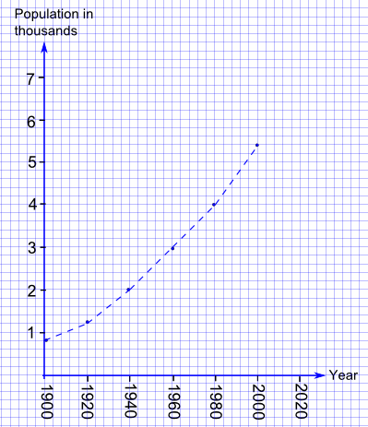

- 400
- 900
- 800
- 850

20. Conditional probability is represented in which of the following situations:

F. A student rolls a die numbered 1 through 6. What is the
probability that she rolls 5 or a 3?

G. A student selects an ace of hearts from a deck of cards.
Without replacement, what is the probability of choosing a 2 of
diamonds on the next draw?

H. In a math class, 48% of all students own a skateboard and 39% of
all students own a skateboard and rollerblades. What is the
probability that a student owns roller blades given that the student
owns a skateboard?

J. A student has a large bag of colored cubes. There are 8 blue cubes, 4
red cubes and 3 green cubes in the bag. If the student randomly
picks a cube from the bag, what is the probability that the cube is
NOT red?

STOP

